**DAILY ONLINE ACTIVITIES SUMMARY**

|  |  |  |  |  |  |  |  |  |
| --- | --- | --- | --- | --- | --- | --- | --- | --- |
| **Date:** | **31-05-2020** | | | | | **Name:** | **Anix Jugal D’Cunha** | |
| **Sem & Sec** | **8 sem , A sec** | | | | | **USN:** | **4al16cs013** | |
| **Online Test Summary** | | | | | | | | |
| **Subject** | | **IOT** | | | | | | |
| **Max. Marks** | | **20** | | **Score** | | | **17** | |
| **Certification Course Summary** | | | | | | | | |
| **Course** | **Python For Beginners – Learn all the Basics of Python** | | | | | | | |
| **Certificate Provider** | | | **Udemy** | | **Duration** | | | **5 Hours** |
| **Coding Challenges** | | | | | | | | |
| **Problem Statement:** Find the Quadratic Equation | | | | | | | | |
| **Status: Completed** | | | | | | | | |
| **Uploaded the report in Github** | | | | | **yes** | | | |
| **If yes Repository name** | | | | | **alvas-education-foundation/dcunhaanixjugal** | | | |
| **Uploaded the report in slack** | | | | | **yes** | | | |

Online Test Details: (Attach the snapshot and briefly write the report for the same)

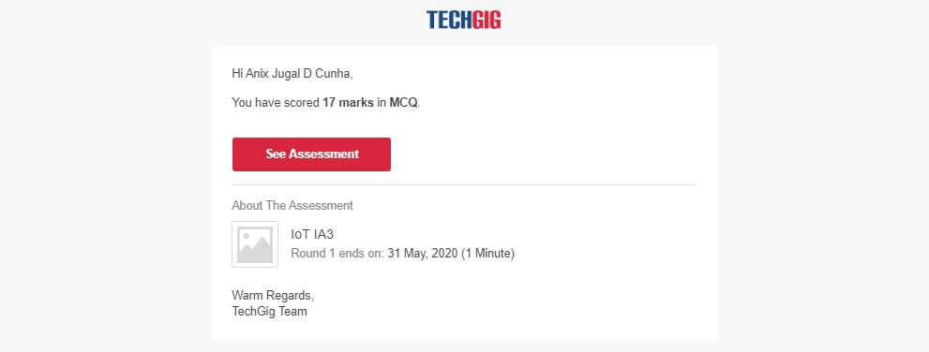

Certification Course Details: (Attach the snapshot and briefly write the report for the same)



Coding Challenges Details: (Attach the snapshot and briefly write the report for the same)

Program 🡪Find the Quadratic Equation

#include <iostream>

#include <cmath>

using namespace std;

int main() {

float a, b, c, x1, x2, discriminant, realPart, imaginaryPart;

cout << "Enter coefficients a, b and c: ";

cin >> a >> b >> c;

discriminant = b*b - 4*a*c;

if (discriminant > 0) {

x1 = (-b + sqrt(discriminant)) / (2*a);

x2 = (-b - sqrt(discriminant)) / (2*a);

cout << "Roots are real and different." << endl;

cout << "x1 = " << x1 << endl;

cout << "x2 = " << x2 << endl;

}

else if (discriminant == 0) {

cout << "Roots are real and same." << endl;

x1 = (-b + sqrt(discriminant)) / (2*a);

cout << "x1 = x2 =" << x1 << endl;

}

else {

realPart = -b/(2*a);

imaginaryPart =sqrt(-discriminant)/(2*a);

cout << "Roots are complex and different." << endl;

cout << "x1 = " << realPart << "+" << imaginaryPart << "i" << endl;

cout << "x2 = " << realPart << "-" << imaginaryPart << "i" << endl;

}

return 0;

}